# Kailey Johnson and Chriss Oboa

# Quiz 6 – MATH 213

I have a dataset containing data on movies released in Hollywood between 2007 and 2013. Here is the codebook:

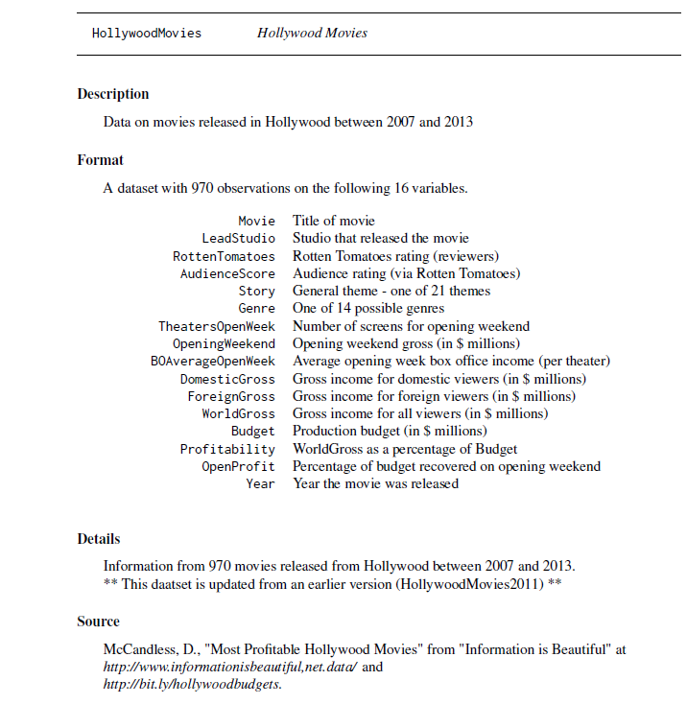

I am looking only at the genres Comedy and Horror. Here is a graph of the variable WorldGross grouped by Genre:

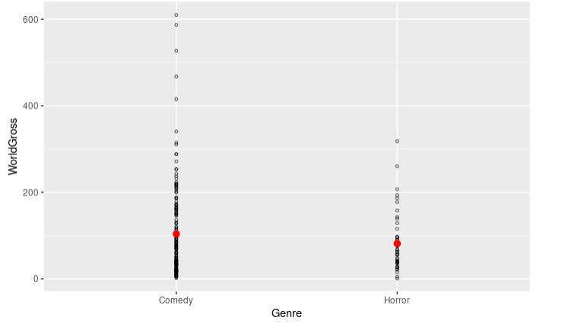

I am interested in understanding how the genre of the movie (comedy or horror) influences the WorldGross figure. (Read the codebook for what this is.) I created a regression model using Genre as a predictor for WorldGross. Here is the model summary output:

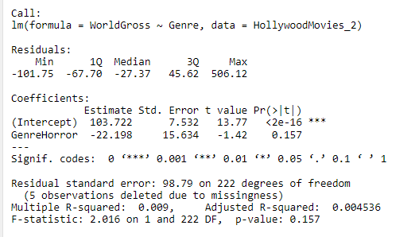

1. Write the regression equation.

WorldGross_hat = 103.722 – 22.198 * (GenreHorror)

1. Write sentences of interpretation for the slope and intercept.

The intercept of 103.722: is the predicted the WorldGross in dollars of movies that are not categorized as a horror movie. (When the horror movie genre is equal to 0).

When looking at the World Gross income, per every horror movie released, there is a -22.198 decrease in the world gross income compared to that of a comedy movie.

OR

When only looking at the WorldGross of a movie that is categorized as a horror movie compared to the WorldGross of a movie that that is not categorized as a horror movie, the predicted WorldGross of a movie that is categorized as a horror genre, on average, decrease by 22.198.

From the same data set, I create another model. Here is the relevant graph.

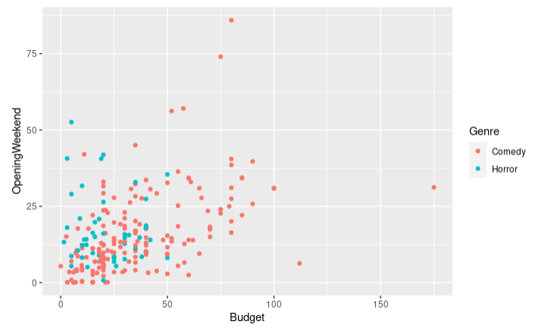

And here is the model summary output.

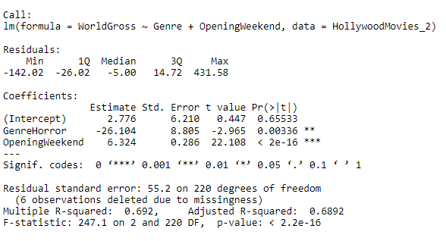

1. Which variable(s) am I using as predictor variables? Categorize them as numerical or categorical. Which variable is the response variable here?

The response variable is the WorldGross income and is numerical.

The explanatory or predictor variable is the opening weekend and GenreHorror which are categorical.

1. Write the regression equation based on the model summary output.

WordGross_hat = 2.776 - 26.104*(GenreHorror) + 6.324*(OpeningWeekend)

1. Write three separate sentences interpreting each of the model coefficients, as we have been practicing.

The intercept of 2.776 is the predicted WorldGross in millions of dollars of movies that are categorized as a comedy movie and hasn’t an opening weekend gross.

The coefficient of -26.104: Whether the movie has opening weekend, when comparing movies that are categorized as a horror movie and movies that are categorized as a comedy movie, the predicted WorldGross earnings of a movie that is categorized as a horror movie is, on average, less by 26.104 million dollars compared to the one categorized as a comedy movie.

The coefficient of 6.324: Whether the movie is categorized as a horror movie or comedy movie, when comparing movies that has an opening weekend gross and movies that hasn’t an opening weekend gross, the predicted WorldGross earnings of movies that has an opening weekend gross is, on average, more by 6.324 million dollars compared to the one movies that has not an opening weekend.